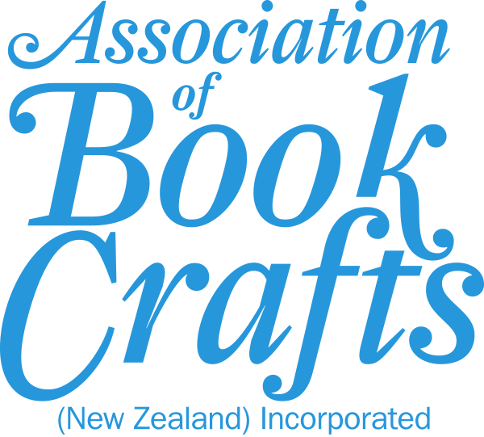 | Bookbinding Tuition  Traditional and innovative book art
We encourage members to tell us about the workshops and courses that they want. Workshops are taught by experienced NZ members and overseas tutors. Keep an eye on ABC’s website, Facebook page and Instagram account for information about upcoming workshops/courses/online options:
Website: http://abc-nz.org.nz
Facebook: https://www.facebook.com/NewZealandABC
Instagram: https://www.instagram.com/abcnzinc/
The following information is offered in good faith and should not be considered a recommendation:
Key: | Traditional bookbinding |  | Both traditional and book art |  | Book Art

Name, location | Phone, email, web | Comments
David Ashman  Auckland | (09) 555-2138  david@bookstudioone.co.nz  https://bookstudioone.co.nz | Book and paper conservator with over 40 years experience in the field. Experienced tutor/presenter available for book and paper conservation advice, tuition and talks, fee negotiable.
Vanessa Robb-Marsh  Auckland | 021 293 5331  kaosv2@yahoo.com | Generally tutors at medieval events in Auckland or Christchurch. Focus is pre 17th century binding - either all medieval techniques or how to adapt medieval techniques with modern materials. Tutors for a fee with material costs included.
Brian Fitzsimons  Hastings | (06) 874 9874 OR 0276002588  brimarbooks@gmail.com  www.bookbinding.co.nz | Will share workshop and knowledge at no charge for enthusiasts. Has taught bookbinding at night school classes and is always available for help and advice.  Commercial bookbinder with lots of machinery, materials etc.
Terrie Reddish  Havelock North | (06) 877 8040 or 021 182 3440  imprimo@terrie-reddish.co.nz  www.terrie-reddish.co.nz | Free advice, tutors at home or away for a fee. Offers in person and Zoom workshops for beginners to intermediate level.
Jill Rose  Masterton | (06) 372 5992  spellbound-binding@outlook.com  www.spellbound-binding.co.nz | Traditional binding advice and one on one tutoring for free. Will run workshops for up to 4 people – fees and details to be agreed at time of enquiry.  Qualification: Trade Certificate.
Anna Nelson  Wellington | 021 033 1505  annanelson456@gmail.com | Runs small fun workshops by appointment in bookbinding, book arts and printmaking.  Anna has a degree in Visual Arts and Design.
Sandy Corbett  Christchurch | 021 101 5362  bookbinder49@gmail.com | Free advice. One on one tutoring and small classes by arrangement, from basic to intermediate in traditional bookbinding, eco books, art books and boxes. Advice and tuition on book repair and restoration.
Yinghua (Jan) Jiang  25 Longmuir Street, Ilam, Christchurch 8041 | 021 298 5171, (03) 358 7353  wyrcan@hotmail.com  https://wyrcanbookbinding.nz | Provides one on one tuition in her studio for a fee. Will travel to run short course workshops, ranging from from beginner classes to advanced leather bindings. Primarily teaches traditional binding, but can also guide design students to do various kinds of designer binding or to experiment with binding styles to fit the projects (which can be quite modern and experimental).  Graphic designer with an arts degree.

